Answering Questions Using the AMIMS Admin Page

Answering Questions Via the Search Bar
The search bar searches every field of the selected AMIMS object. Searches are case insensitive. For example, Searching “Colorado River” in the Project object will return every project that contains the words “Colorado River” in any field.

Answering Questions Via Advanced Filters
Advanced filters are more complex than the search bar but offer much more granularity. To create an advanced filter click on the advanced filter button at the top right of the admin page. This will bring up a pop up that contains the form for creating an advanced filter. Each advanced filter must have a title and at least one filter, filters are added with the ‘Add another filter’ button at the bottom left of the pop up. Each filter has five fields; field, operator, value, negate, and delete. Negate and delete are optional, but the other three are required. Field refers to the field to be searched in the AMIMS object, e.g. the Project object contains the fields Worktask ID, Project Status, Conservation Measure Code, etc. Field also contains the OR operator which we will discuss later. The operator drop-down holds a set of logical operators that preform the main action of the search. The value field will contain the actual search value. This field is acts like a text box, but is in fact a semi-searchable drop down. If you would like to search for a value not contained in the generated list simply type into the box and click on your typed entry. Please note that values are case sensitive. The negate field is a tick box and will invert the logic of the filter. For example, if the filter is set to search for all projects whose worktask IDs begin with ‘C’, the negate option will change it to search all projects whose worktask IDs do not begin with ‘C’. Finally, the delete field is another tic box that will delete the filter after it has been used. Normally advanced filters are saved so that they can be reused later, but selecting this option will prevent this from occurring.

Example 1
In this example we will use the search bar to find every project object that contains the phrase “Colorado River” in any field as described earlier.

1. Enter the search phrase into the search bar and click the Search button or press the Enter key. Note that the phrase does not need to be case consistent.
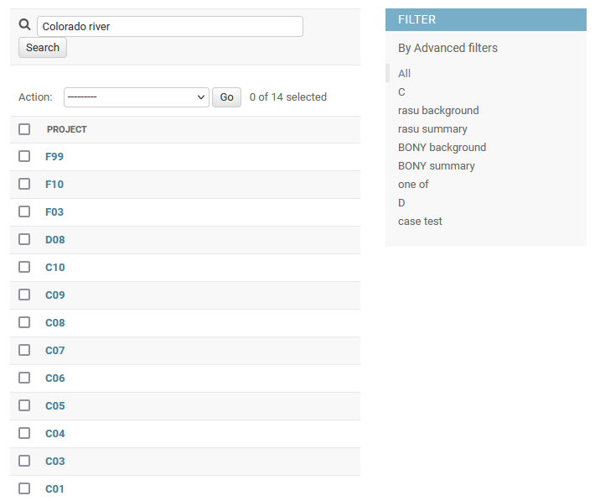

2. You can now see that we have a filtered selection of projects that contain our search phrase.
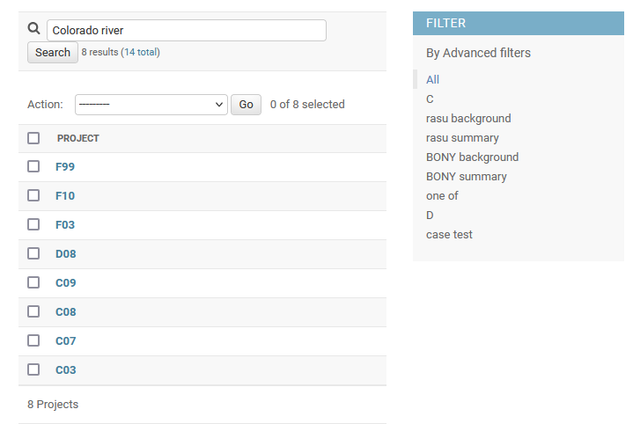

Example 2
In this example we will use advanced filters to search for projects that contain the phrase “Colorado River” but only in the project summary field.

1. Click on the Advanced Filter button at the top right of the page to bring up the advanced filter form.
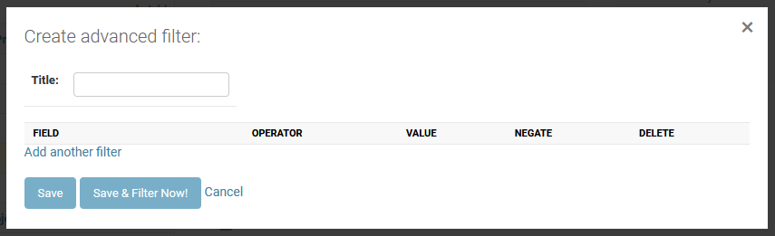
2. Type the name of the filter into the “Title” box, we’re going to name our filter “Colorado River Summary”. Then click on “Add another filter” to add an empty filter.
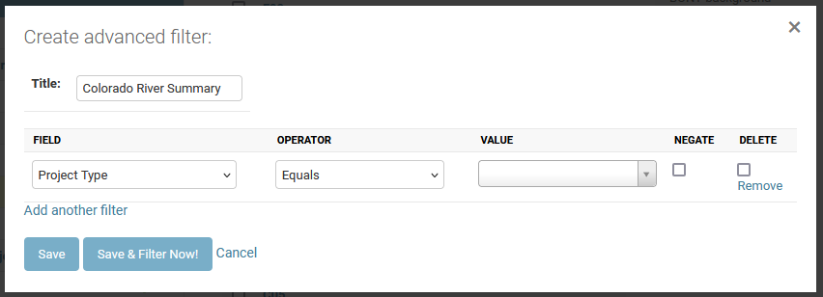
3. In the filter change the field to “Project Summary”, the operator to “Contains”, and type “Colorado River” into value. Remember to click on “Colorado River” rather than pressing the enter key. Please also note that the value field is case sensitive. Once we’ve done this click on the “Save & Filter Now!” to preform our search.
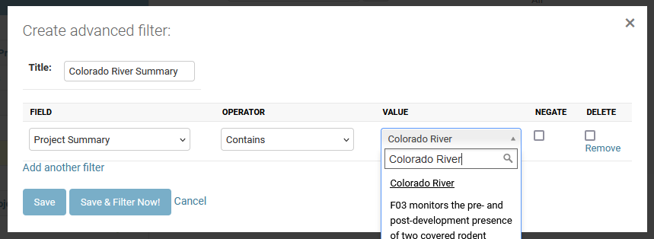
4. You can now see that we have a filtered list of projects that mention “Colorado River” in the project summary. Also, notice that in the “Filter” side bar our filter is selected. If we wished to preform this search again all we would need to do is select “Colorado River Summary” from this list.
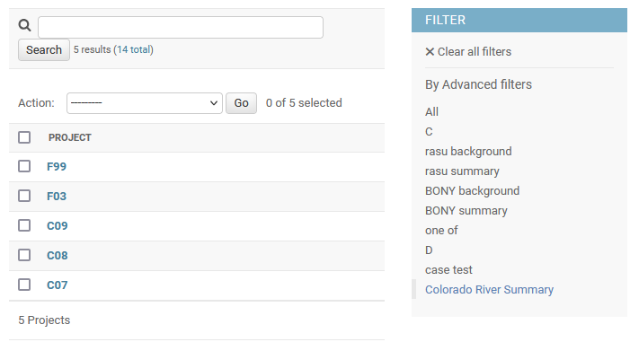

Example 3
In this example we are going to use advanced filters to preform a much more complex search. We are going to filter step objects by types that include “Statistical analysis” or “Field data collection” but aren’t in our example worktask F99.

1. Like in example 2 start by creating an advanced filter and naming it. We’re going to name ours “Analysis and Data sans F99”.
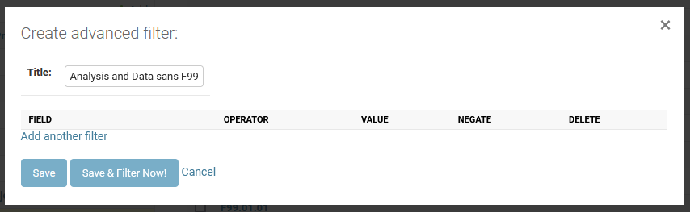
2. To filter types by “Statistical analysis” or “Field data collection” we’re going to need five filters. Our first two filters will be “Step Type Contains Statistical Analysis” and “Step Code Contains F99” with the negate box ticked to invert the filter. Our third filter is the OR operator. This operator is found at the bottom of the field drop-down and allows us to separate blocks of filters. Filters four and five are similar to one and two but for “Field data collection”.
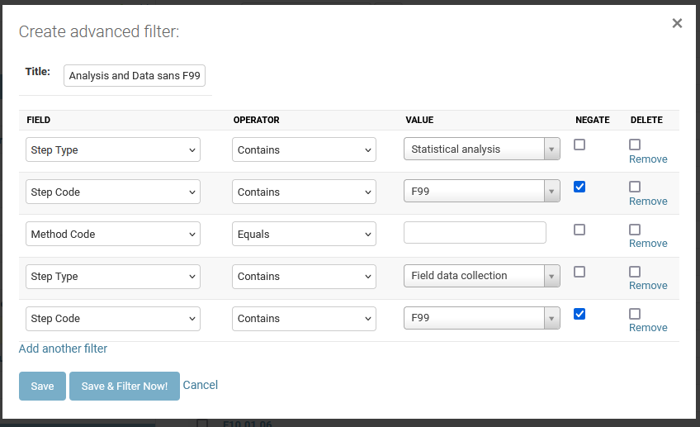

3. We now have a filtered list that only contains steps that match our search terms.
